FOR IMMEDIATE RELEASE
OCTOBER ​2^{ND,} 2020

SHANGA
​
RELEASES ELECTRIFYING DEBUT ALBUM

“BOLD”

OUT TODAY
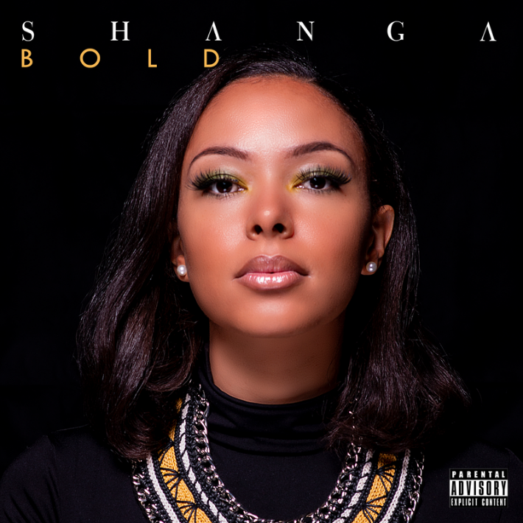
LISTEN / DOWNLOAD HERE

The Swiss- Nigerian artiste, Shanga, releases her debut album titled "Bold" and captivates her audience with a unique and eclectic sound.
Her debut Album combines the best worlds of Rhythmic Soul, Afro Beats, Rap and Jazz. It was primarily produced by her spouse "Beat-Chronicles" (Bisi Udemba) and also features tracks produced by Mr. Kleb and Tony Robinson.​
Bold as the title denotes, Shanga explores new genres which she describes, made her feel empowered through the making of the album.
TRACKLIST
- INSIDE OUT………………………………………………...……………02:59
- EBAH-EBAH……………….……………………..………………………03:18
- KELELE…………………………………………………………………..03:25
- A CROWN…………………………………….…………………………..03:16
- DOWN LOW………………………………………..…………………….02:57
- ANYTIME…………………………………………………………………02:44
- CERTIFIED………………………………………………………………..03:24
- MAGNITO………………………….……………………………………..01:58
- BOLD………………………………….……………….…………………..02:22

CONNECT WITH SHANGA
WEBSITE | INSTAGRAM | TWITTER | FACEBOOK | YOUTUBE

PRESS CONTACT
Anthony Udemba | management@shangaofficial.com

