FOR IMMEDIATE RELEASE
APRIL ​3^{RD,} 2020

SHANGA
SHANGA EXPLORES NEW GENRE WITH

SINGLE AND VIDEO

“CERTIFIED”
OUT TODAY

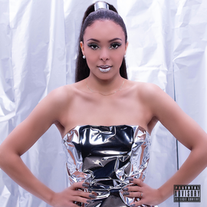
LISTEN NOW

Today Shanga, the Swiss-Nigerian star on the rise, who has opened up for African legend 2Baba (TuFace Idibia) is the artist to look out for in 2020 as she taps into a fusion of Grime and Afro with her latest single titled "Certified". Watch video here.
The song was mixed and mastered by Grammy nominated “Ben Mühlethaler” for his works with the legendary Prince.
This is the first single from her upcoming Album which is set to be released this year.
Swiss Bund newspaper has stamped their approval by stating “Shanga is headed for world domination”

CONNECT WITH SHANGA
WEBSITE | INSTAGRAM | TWITTER | FACEBOOK | YOUTUBE

PRESS CONTACTS
Anthony Udemba | management@shangaofficial.com

